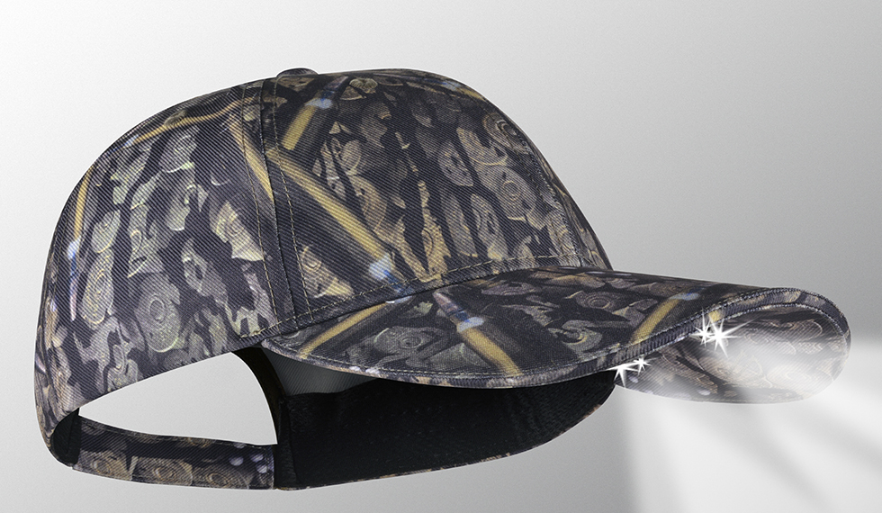
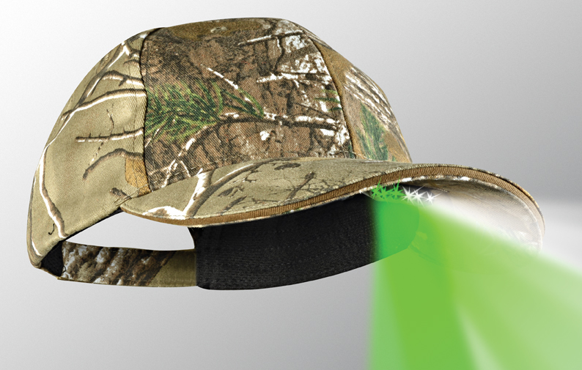
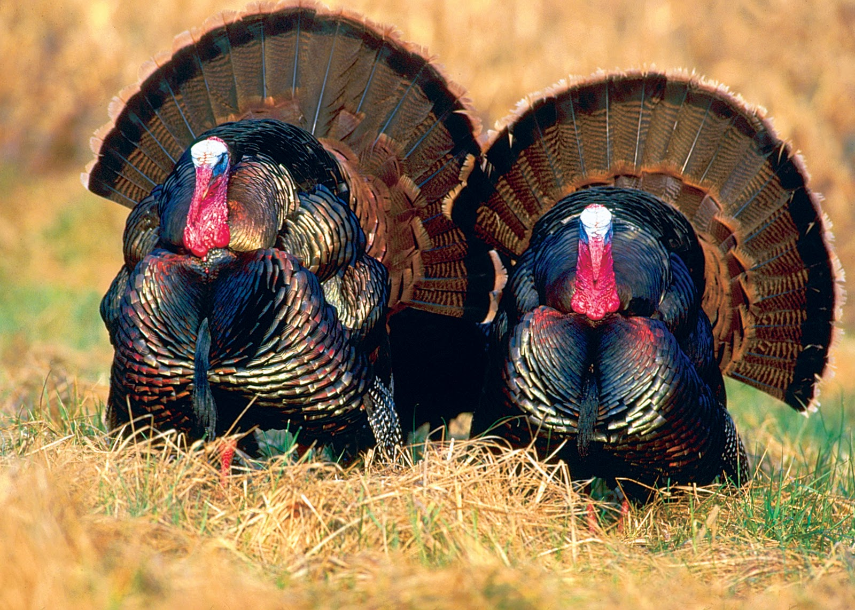
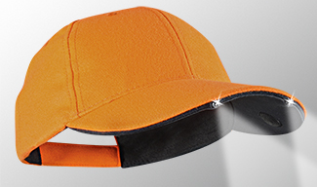
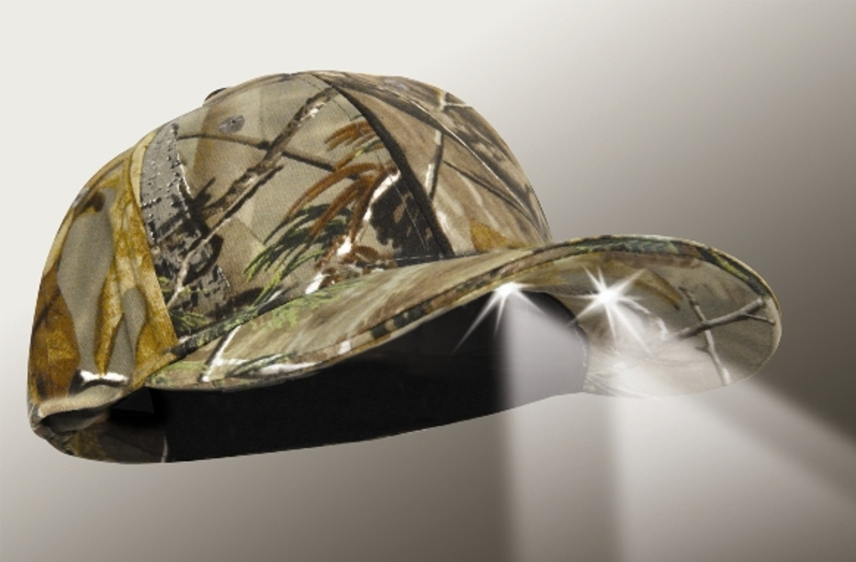
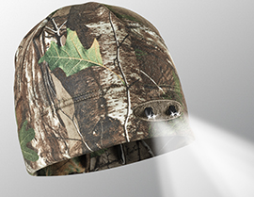

VISIT OUR WEBSITE WWW.PANTHERVISIONPROMO.COM
TO SEE THE FULL LINE OF LIGHTED PRODUCTS
OR CALL 847.783.5900 x 116 FOR MORE INFORMATION

VISIT OUR WEBSITE WWW.PANTHERVISIONPROMO.COM
TO SEE THE FULL LINE OF LIGHTED PRODUCTS
OR CALL 847.783.5900 x 116 FOR MORE INFORMATION

PS4-199
PS6-164
Powercap® 3555 realtree xtra lighted beanie WB-4539

$1.00 off each beanie,
Minimum 12 pieces, order in 6s
Through 4/30/17

Great for early morning
or end of day hunts
Calling all Turkey hunters
Caplight (CL2) Series
2 LEDs pointing outward
Available in Blaze Orange and REALTREE Xtra

Add your logo and info here

VISIT OUR WEBSITE WWW.PANTHERVISIONPROMO.COM
TO SEE THE FULL LINE OF LIGHTED PRODUCTS
OR CALL 847.783.5900 x 116 FOR MORE INFORMATION

VISIT OUR WEBSITE WWW.PANTHERVISIONPROMO.COM
TO SEE THE FULL LINE OF LIGHTED PRODUCTS
OR CALL 847.783.5900 x 116 FOR MORE INFORMATION

VISIT OUR WEBSITE WWW.PANTHERVISIONPROMO.COM
TO SEE THE FULL LINE OF LIGHTED PRODUCTS
OR CALL 847.783.5900 x 116 FOR MORE INFORMATION

Stealth 2575 (PS4) Series
4 LEDs pointing outward and downward. Available in Blaze Orange, REALTREE Max 4, REALTREE Pink, True Timber New Conceal, AmmoCamo, Kryptek and REALTREE Xtra in various
options: solid, with blaze orange trim or mesh back
$1.00 off
WB-4539
through 4/30/17
ASI 75825 SAGE 68668 PPAI 318255

VISIT OUR WEBSITE WWW.PANTHERVISIONPROMO.COM
TO SEE THE FULL LINE OF LIGHTED PRODUCTS
OR CALL 847.783.5900 x 116 FOR MORE INFORMATION

VISIT OUR WEBSITE WWW.PANTHERVISIONPROMO.COM
TO SEE THE FULL LINE OF LIGHTED PRODUCTS
OR CALL 847.783.5900 x 116 FOR MORE INFORMATION

VISIT OUR WEBSITE WWW.PANTHERVISIONPROMO.COM
TO SEE THE FULL LINE OF LIGHTED PRODUCTS
OR CALL 847.783.5900 x 116 FOR MORE INFORMATION

Stealth 2500 (PS2) Series
2 LEDs pointing downward
Available in REALTREE Xtra

NightVision (PS6) Series
6LEDs white & green pointing outward/downward. Green LEDs wil not spook deer and assist in blood tracking
Available in blaze orange or REALTREE Xtra

Beanies (WB) Series
4 LEDs pointing outward and downward
Available in REALTREE Xtra, REALTREE Max 5 and Blaze Orange

PS4-163

